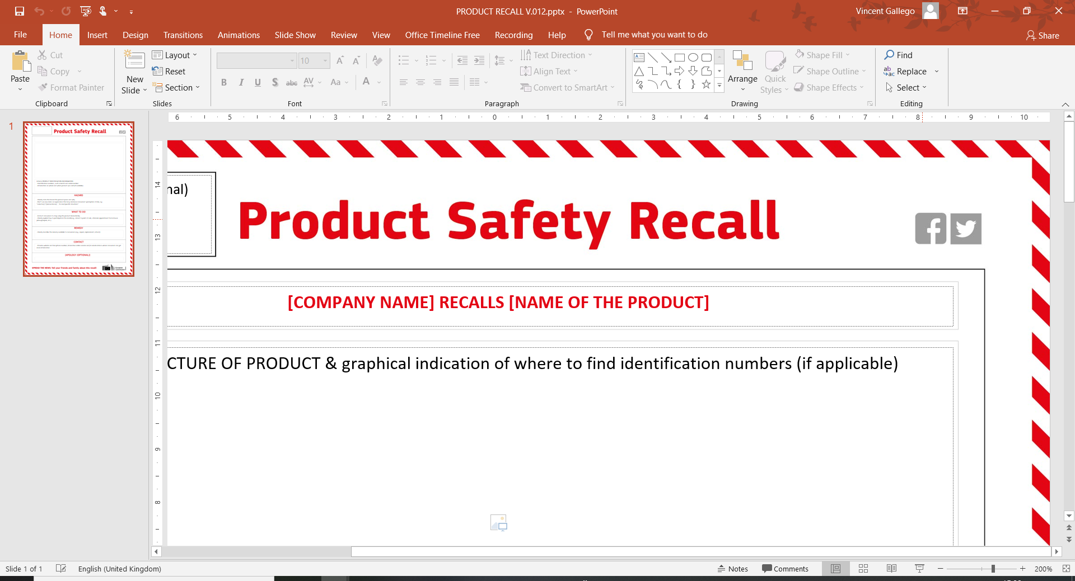
[COMPANY NAME] RECALLS [NAME OF PRODUCT]



Include PRODUCT IDENTIFICATION INFORMATION:
- Identification numbers, such as batch and serial number
- Information on where and when product was sold (if available)

HAZARD
- Clearly state the hazard the product poses and why
- Don’t use any terms or expressions that may decrease consumers’ perception of risk, e.g., “voluntary”/ “precautionary”, “in rare/specific situations”

WHAT TO DO
- Instruct consumers to stop using the product immediately
- Clearly explain how to participate in the recall (e.g., return to point of sale, schedule appointment for in-house pick-up/repair, etc.)

REMEDY
- Clearly describe the remedy available to consumers (e.g., repair, replacement, refund)

CONTACT
- Provide website and free phone number, interactive online service and/or email address where consumers can get more information

[APOLOGY (OPTIONAL)]



